WMDCA player points model: 2025–26

Purpose
The revised Player Points System aims to balance club integrity, competitive fairness, and growth of the competition. It is designed to:
- Discourage internal poaching within WMDCA

- Encourage strong external recruitment, including inter-league and international players

- Reward loyalty and returning players

- Align with the competition structure (Premier & Championship only)

- Raise the standard of cricket across Division 1

- Strengthen efforts to publicise the competition and drive broader interest

This model aims to be clear, fair, and growth-focused.

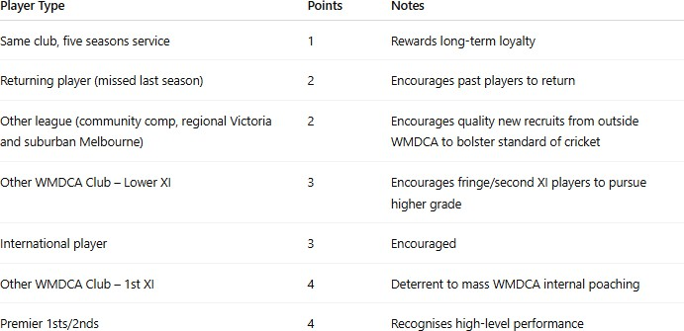

Key features
- Applies only to Division 1 – Premier & Championship

- 24-point cap per team in all Division 1 matches

- Designated International player = 3 points

- One designated, non-international Under 21 recruit from another league/competition: 1 point

- Players who featured in WMDCA in 2024-25 retain value (i.e. a 4-point player would be a 3-point player if they return to the same club due to loyalty provision.

- A returning player recruited as a six-pointer this past season (from Victorian Premier Cricket First and Second XI) will automatically revert to a 4-pointer under new model (i.e. Kalhan Sineth). Returning internationals - if any - will be classed as 3-point players, and so on.

Under 21 designation
- One designated, non-international player under 21 years of age recruited from outside the competition is a one-point player

- This is designed to encourage good young talent to ply their trade in the WMDCA

Team cap – Premier & Championship

Tier | Total Points Cap
Premier | 24
Championship | 24

Why this model matters

- Improving quality lifts the entire comp. Encouraging new players — from other comps or overseas — ensures stronger cricket and closer contests

- Better players bring more attention. With quality cricket comes the opportunity to promote the competition, clubs and sponsors, showcase standout performances, and engage the broader community

- Clubs remain in control. With clear rules and flexibility in recruitment, clubs can still build in a way that suits their culture and strategy

- Strong focus on retention and rewarding loyalty

