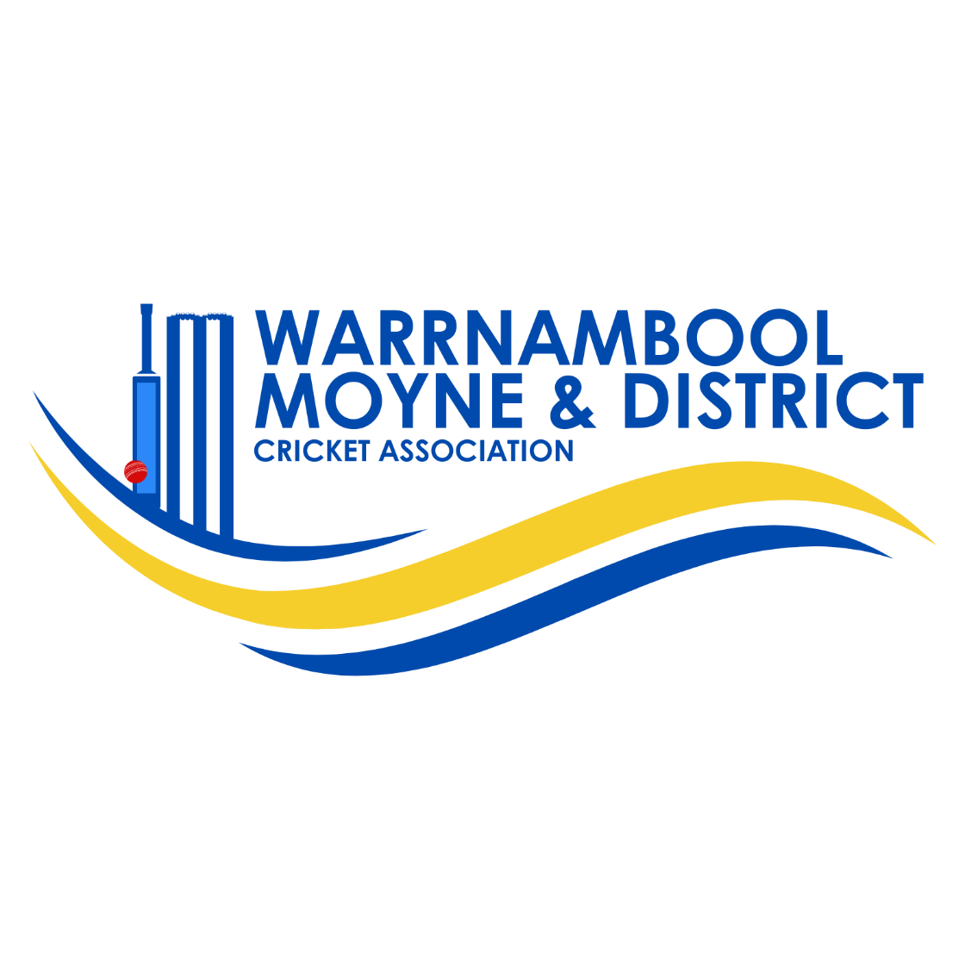

GIRLS U17’s
Beyond Bank
PLAYING CONDITIONS
SEASON 2025/26.

Last Updated 25 September 25

WMDCA Under 17 Girls Competition Playing Conditions.
General Conditions
Matches under the WMDCA Girls Renegades Cricket Competition will be played on Wednesday afternoons commencing at a time and venue as determined in the approved playing schedule as provided by the Girls Cricket organising Committee.

Age Levels
Players must be Under 17 as of the 1^{st of} September of each year to be eligible to play in those age groups.
Overage players dispensation is permitted where special circumstances exist and approval is granted by the director of Girls cricket, with restrictions applying.
All players must be registered online on the Competition Management Platform prior to playing their first game. The registration must include a name and address, player date of birth and an email address and parent/s phone contact details. Failure to comply may result in loss of match points.
All Coaches and Team Managers must possess a current Working with Children Check accreditation. It is WMDCA policy that team coaches attend and attain a Level 1 community coaching accreditation qualification prior to or during the current season.
All coaching officials are responsible for the general conduct of their players and spectators and players must adhere to the Spirit of Cricket principles and confirm with the WMDCA Player and Coaches Code of Conduct.
Each team is required to provide an umpire for each scheduled match.

Match Format: Girls Under 17’s
Standard T20 Rules Apply.
Matches are to be played at the first named Clubs venue.

Duration of Play -One Day Matches
Each team shall bat for 20 overs unless dismissed earlier. The second batting team is entitled to their allotted 20 overs if not dismissed. A minimum of 5 overs per team constitutes a match.

Hours of Play – 1 hour 15 minutes batting time each innings.
5pm to 6.15pm - 1st Session.
6.15pm to 6.30pm- Innings break
6.30pm to 7.45pm- 2nd Session.

Two Day Quarter Cricket Model.

In all two day matches 40 overs are to be bowled each day. After the first 20 overs the first batting team innings will stop and then the second team will commence its innings and bat for 20 overs. On the second day batters at the crease on day one will continue to bat for a further twenty overs unless the team is dismissed. The second team will then re-commence its innings and face their twenty overs entitlement. The innings will continue until the 10th wicket falls or the 20 overs allocation has been bowled.
The final score is recorded at the fall of the 10th wicket, or after the completion of the entitled overs having been bowled.
In the two day format a batter will retire after reaching 50 runs. That retirement does not equate to a fall of wicket.
Ground size
The Ground size should be 40 metres in length measured from the centre of the pitch.

Teams
All teams can comprise of a maximum 12 players. Games are permitted to be played where there are 6 players or more in each team. Players can interchange on to the field without restriction at any time. Only 11 players can bat or bowl. A wicketkeeper can be a batter.

Batting- T20 format
Players will retire after reaching 40 runs. Where teams have less than 11 players, a player may bat for a second time, returning to bat in order from lowest score to highest score. This includes non- compulsory retired players.
Once 10 wickets fall, the innings is complete.

Bowling
4 overs maximum per bowler in 2 over spells on each day’s play.
It is recommended that all players in the team bowl at least one over.
A bowler is unable to commence a second or subsequent spell until the same amount of overs have been bowled on completion of the bowlers spell.
A maximum of 8 balls per over to be bowled irrespective of no balls or wides bowled.
The last over of any innings must have 6 legal deliveries regardless of wides and no balls bowled.
Half the overs are to be bowled from one end and then the remaining overs from the opposite end to complete the match.
Fielders to rotate in field every 5 overs.
Front Foot No Balls apply which will incur a free hit to a batter. Off the pitch, balls bouncing twice and over waist high balls are deemed no balls – No free hit applies in these instances.
Lenient leg and off side wide interpretations apply.
LBW only applies when hit on the pads on the full when directly in front of the stumps.
Discretion to be used in enforcing this rule.

Equipment
All Clubs must adhere to equipment standards in Girls Under 17 Matches;
A helmet, keeping gloves and pads to be worn by the wicket keeper.
Batters must wear approved helmets. Batting pads and gloves are to be worn.
Coloured Clothing
Team Players are to wear approved Club coloured playing tops in Match play. Cricket Whites or other coloured trouser is the desirable standard.

Ball
A Kookaburra brand red 142 gm ball is the approved match ball for day time matches only. White Kookaburra 142 gm balls are the approved ball for twilight matches. Both teams to utilise the same approved coloured ball for the match.

Scoring and Match Results
A scorebook will be supplied by the WMDCA at the commencement of the competition for all teams. All players statistics, wickets, catches and runs are to be recorded as per normal scoring practices.
Match results must be submitted on Competition Management Platform within 72 hours of the completion of the match by either team official. If live scoring, it will be that clubs responsibility to upload the result and player scores. However, both teams are responsible for checking their individual club player statistics are correctly entered within the above timeframe.

Match Points
Win – 6 points
Loss – 0 points
Draw – 3 points
Tie – 3 points per team.
Washout – 3 points each team. ( Draw)
Bye – if uneven number of Byes – 6 points.

Finals Play
Players must have played a minimum of 3 games for that team to be eligible to play in a finals match.
All regular season rules apply for finals matches.
A final series will comprise of the first four teams on the ladder.
Team 1 v Team 4, Team 2 vs Team 3.
The two winners will then play their Grand Final to determine the champion team of the season at a venue to be determined by the Women’s Executive. Two umpires will be appointed, and a WMDCA Grand Final Player of the Match will be awarded on the completion of the match.
Steph Townsend Cricketer of the season award
Votes are to be awarded in each game (4,3,2,1) and submitted to the general manager by the home team coach after consultation with the opposing coach. The votes are to be forwarded within 48 hours after the completion of the match.

Contacts for Girls Cricket
Ingrid Bellman- Director of Girls Cricket. Mobile No. 0431 231 651
Gordon McLeod Women’s Cricket Liaison. Mobile 0408 990 590.

